1. Find out the purpose of the following commands and execute them on your system

with different parameters. [1]

ls, cd, pwd, mkdir, rmdir, rm , cp, mv, touch

ANSWER:

ls: used to list the names of all files/content in the current directory or any other directroy at the moment

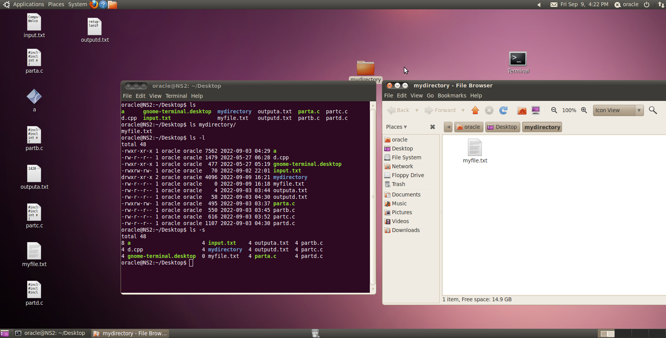

Cd: used to change current directory. Without parameter goes back one directory

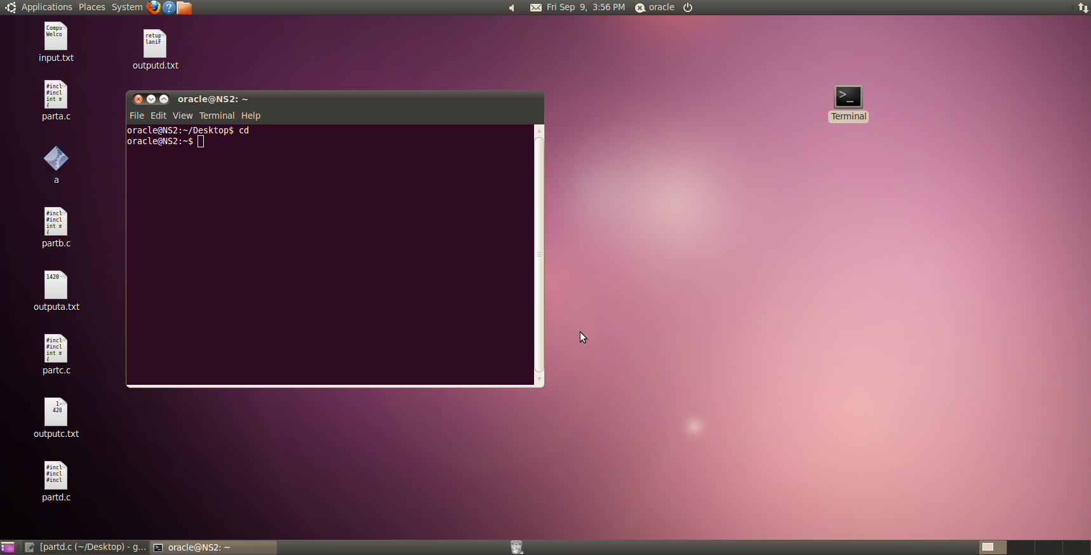

Pwd : prints the path of current directory

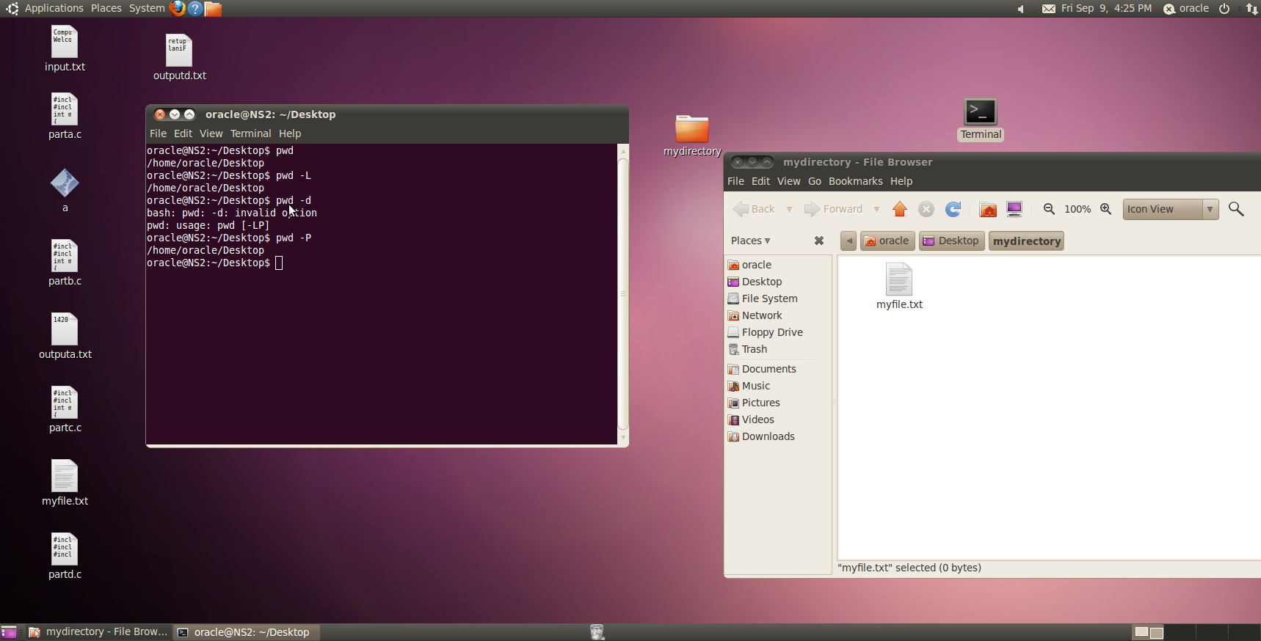

Mkdir: used to make directory.

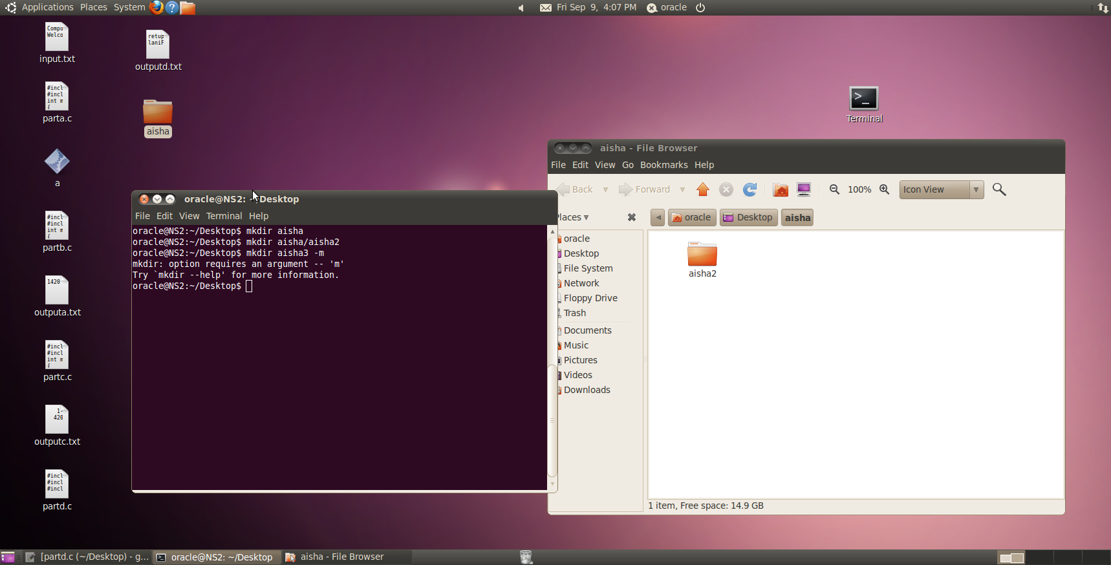

Rmdir: used to remove a certain directory



Rm: remove a file

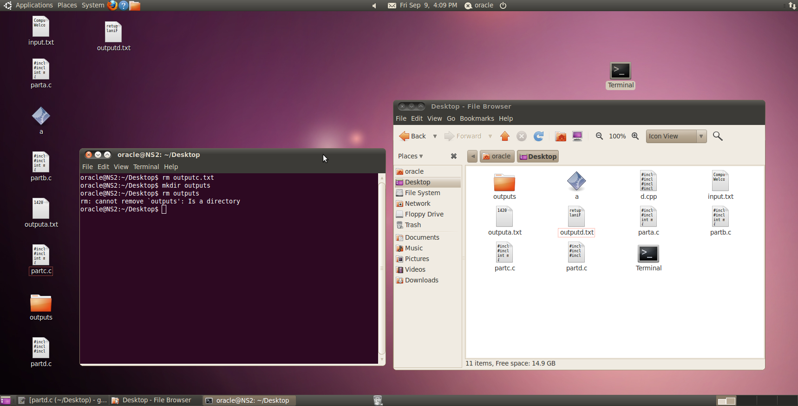

Cp: used to copy files from source to destination

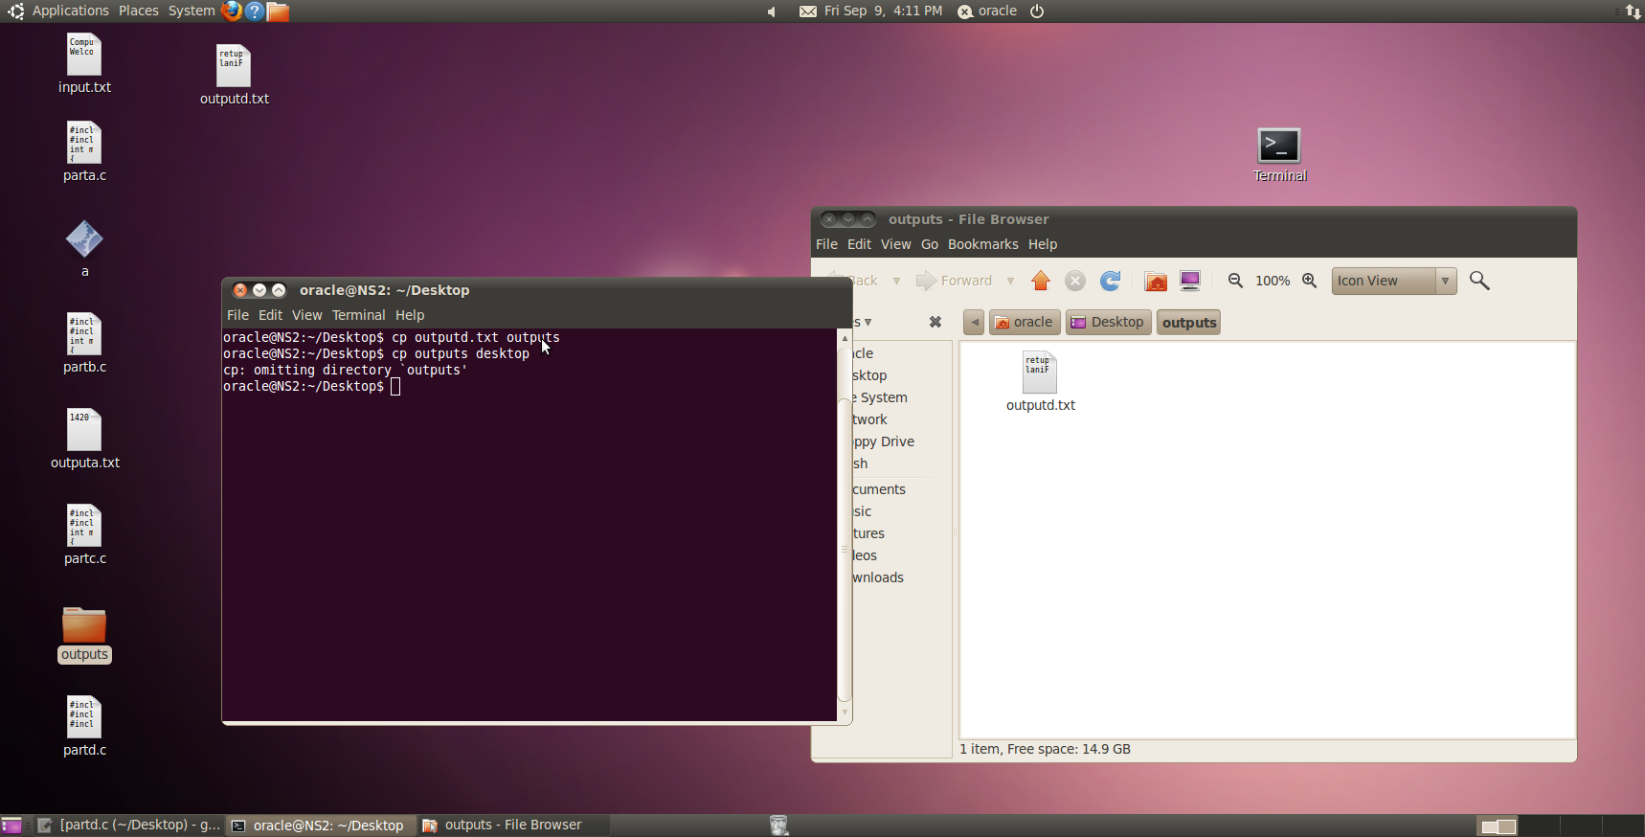

Mv: used to move , not copy from source to destination

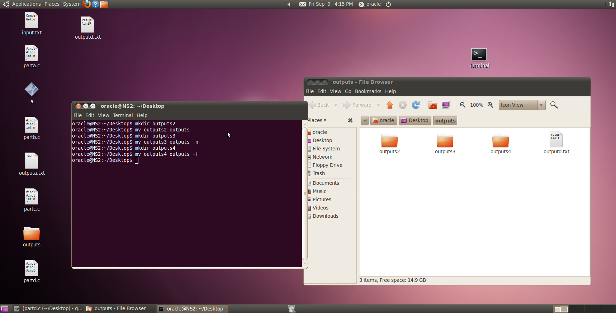

Touch: creates a file or used to change timestamps

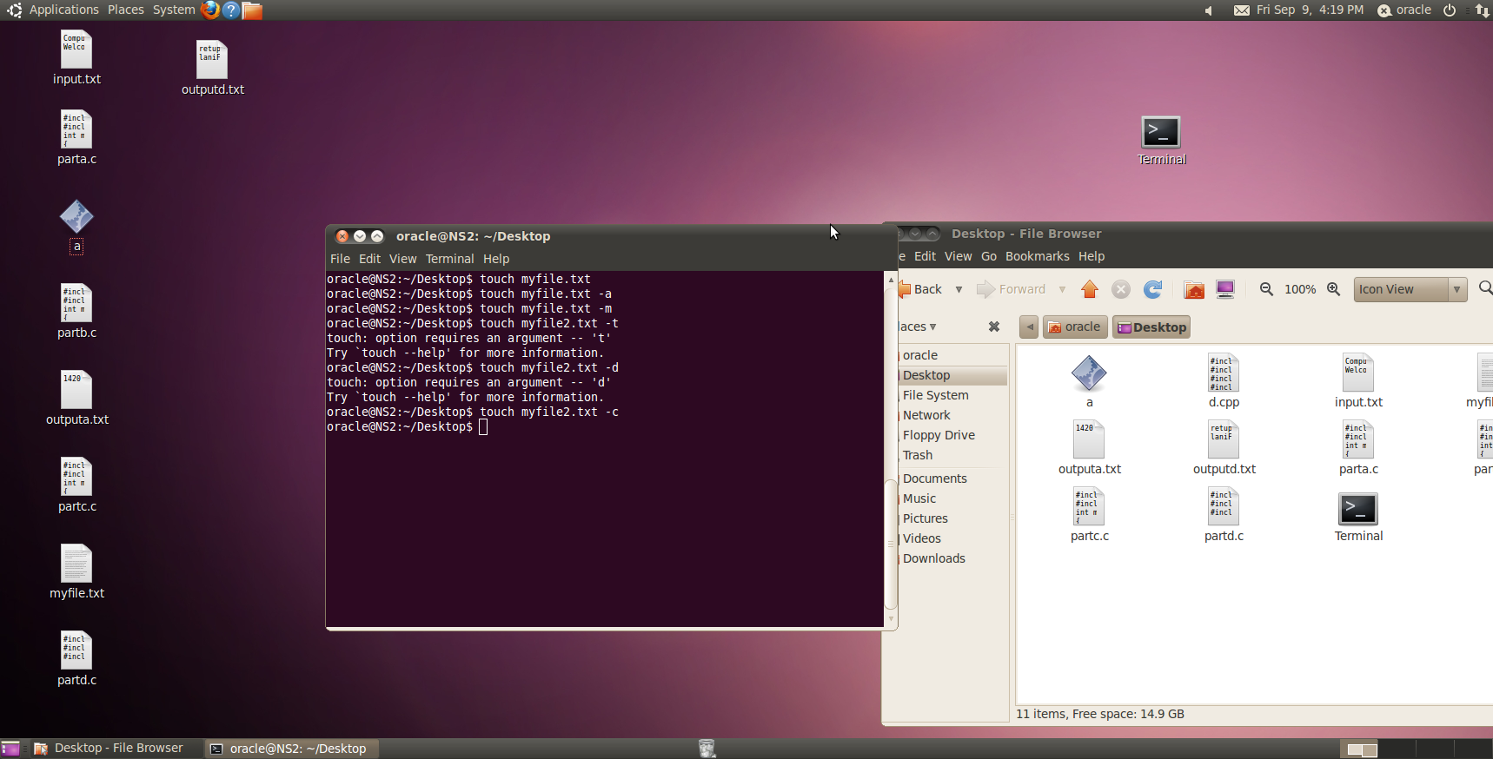

QUESTION 2:

Top:

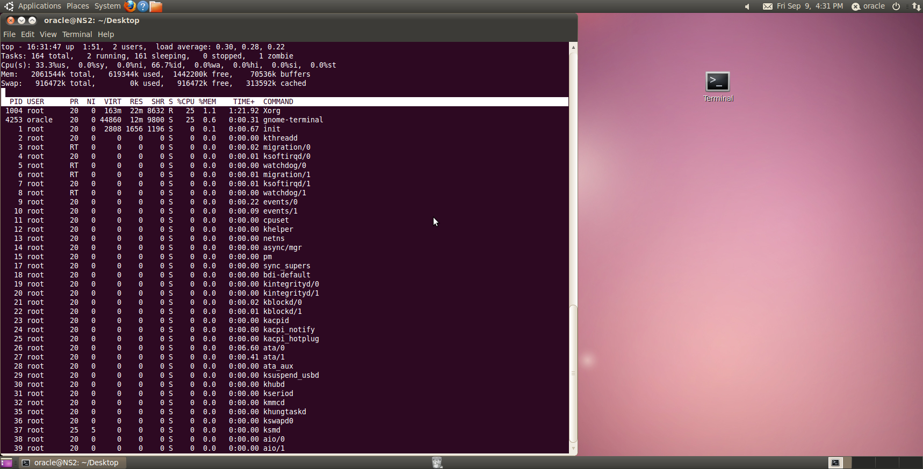

Ps:

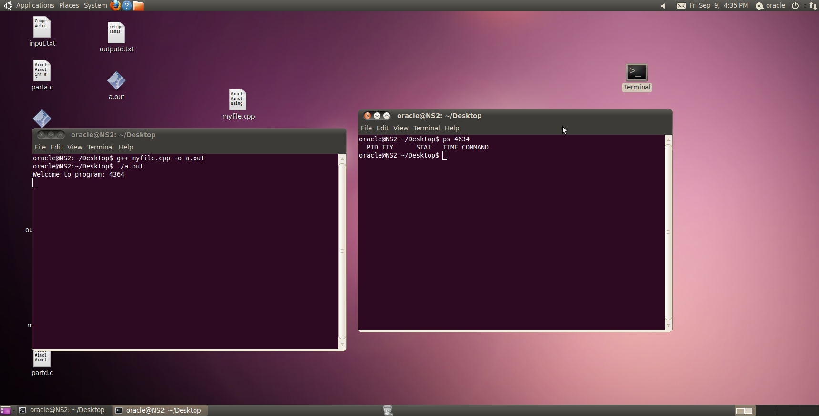

Killpid:

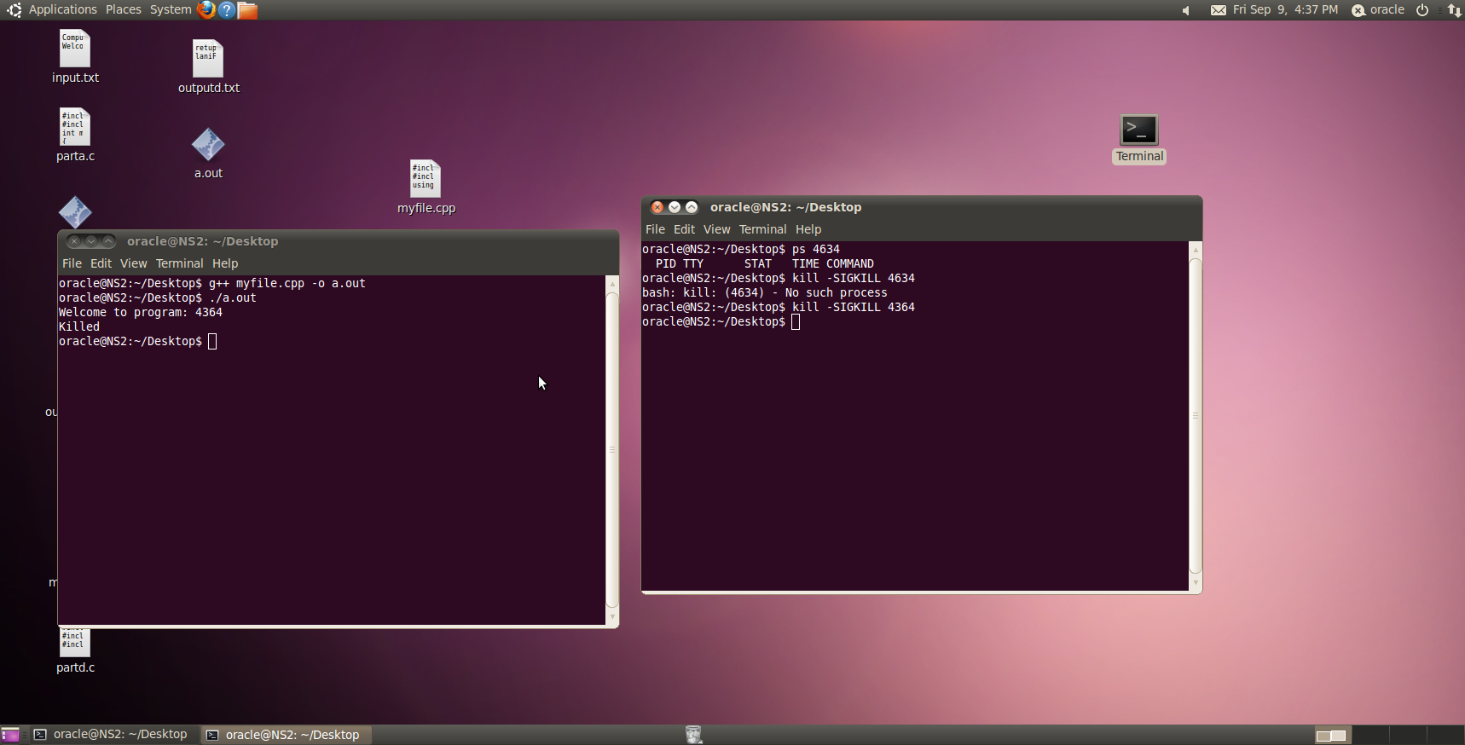

Chmod:

Using chmod 400 lab1.txt: locks my file to read only I cannot edit it.

Using chmod 700 lab1.txt : unlocks my file I can again edit and read from the file.

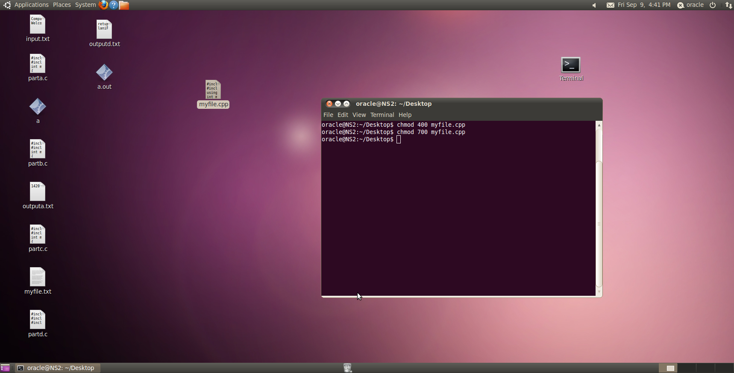

Ifconfig:

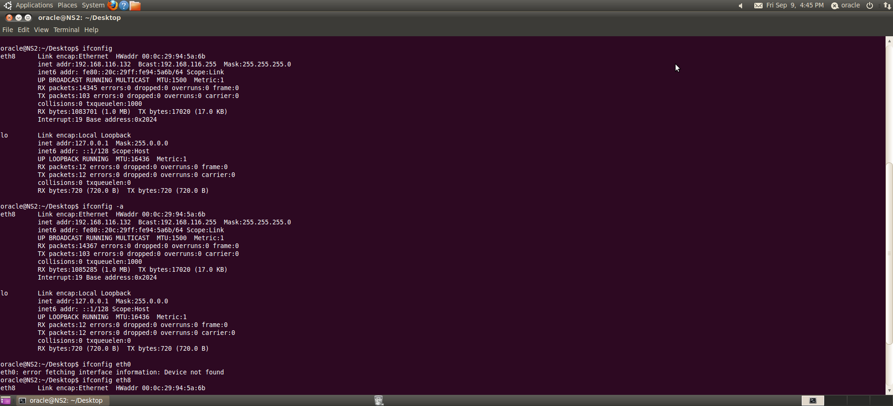

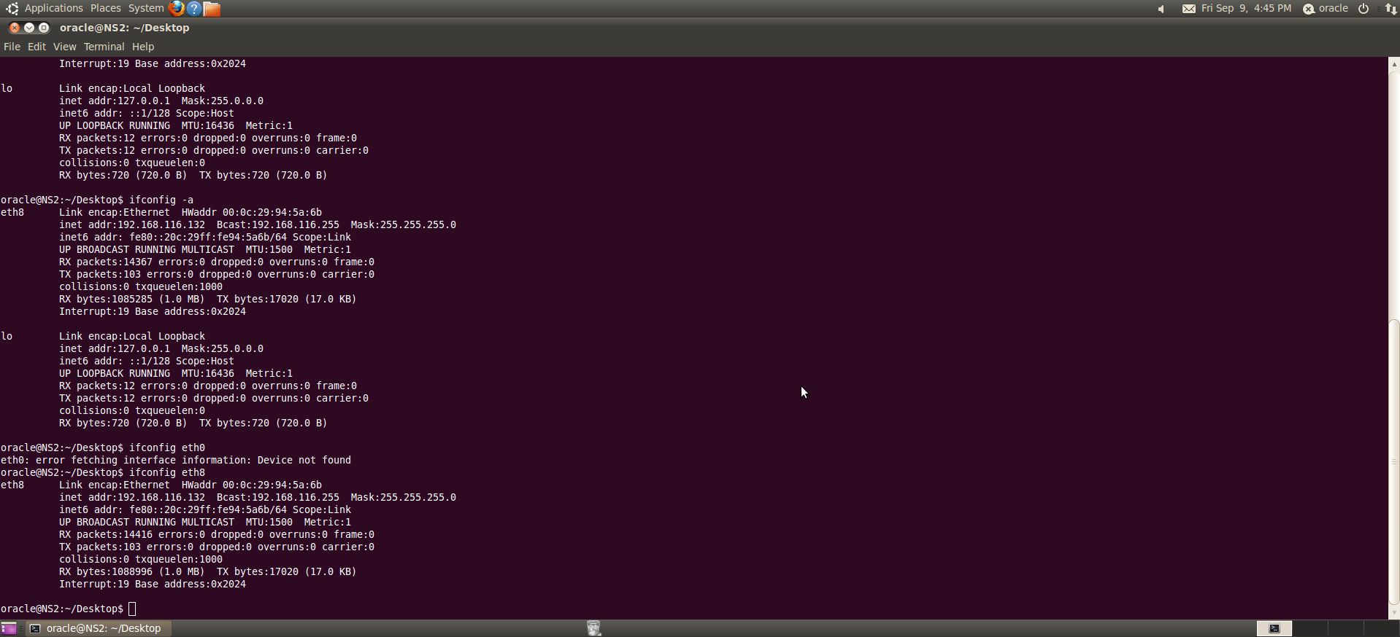

Route:

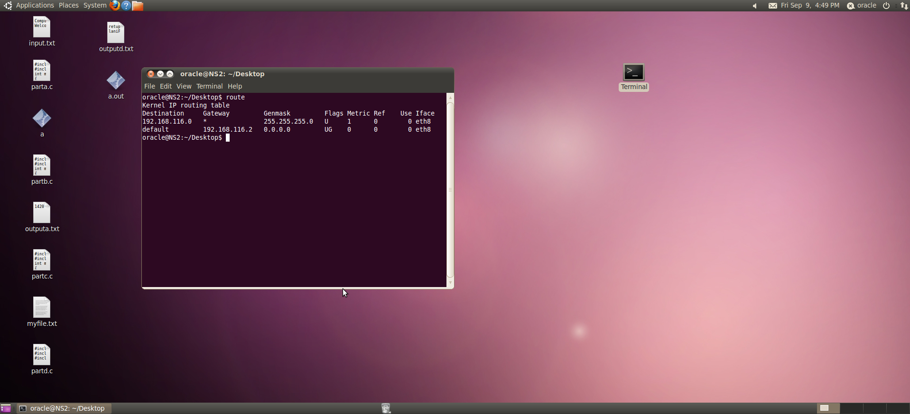

Ss:

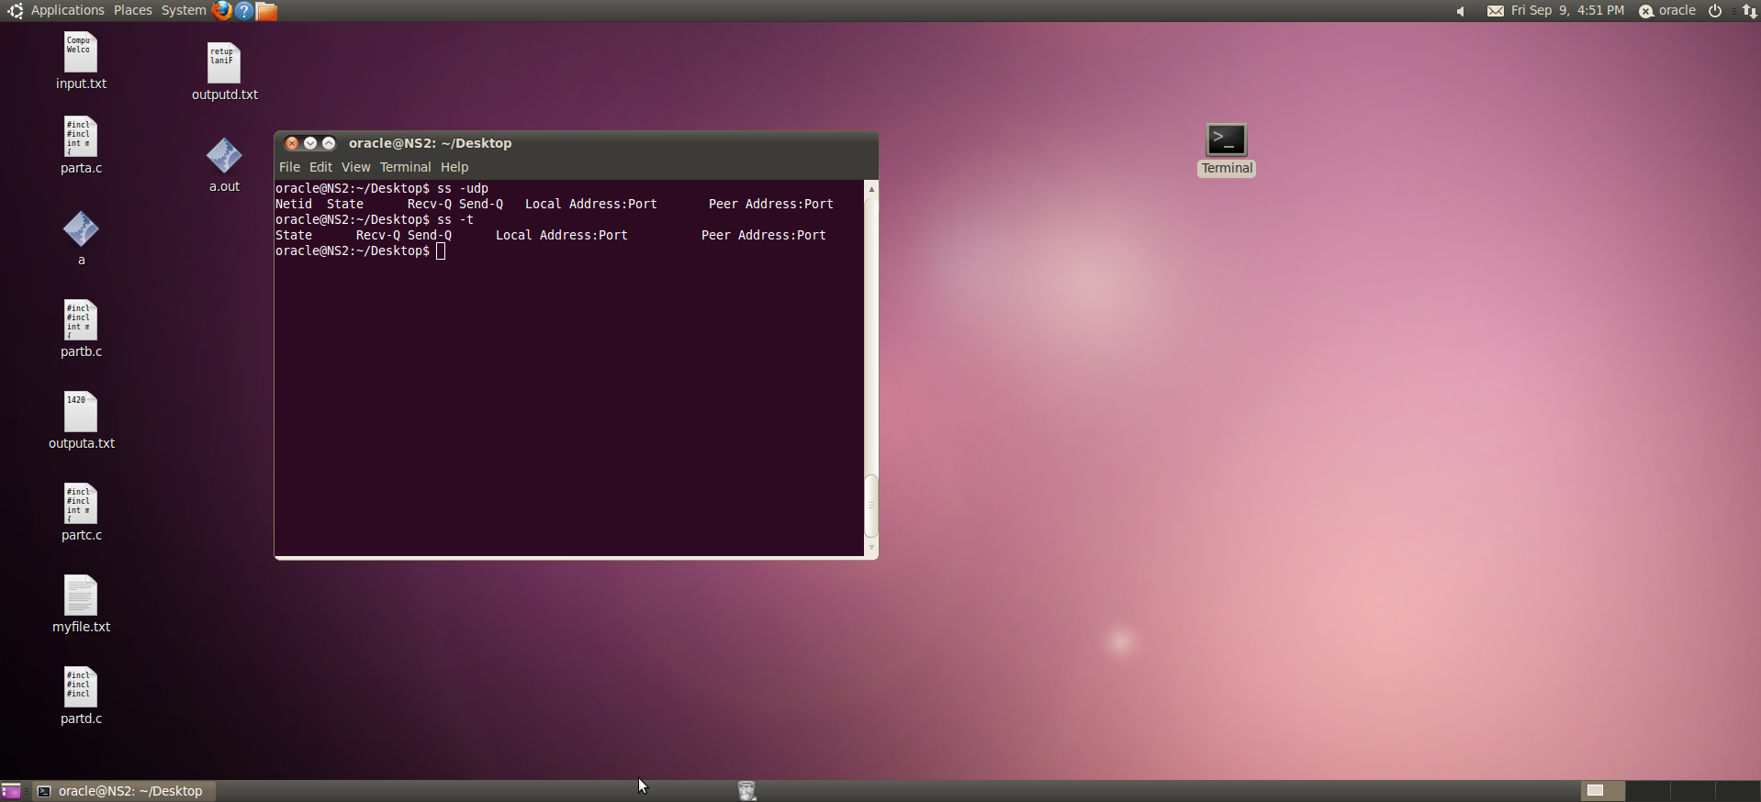

Wget:

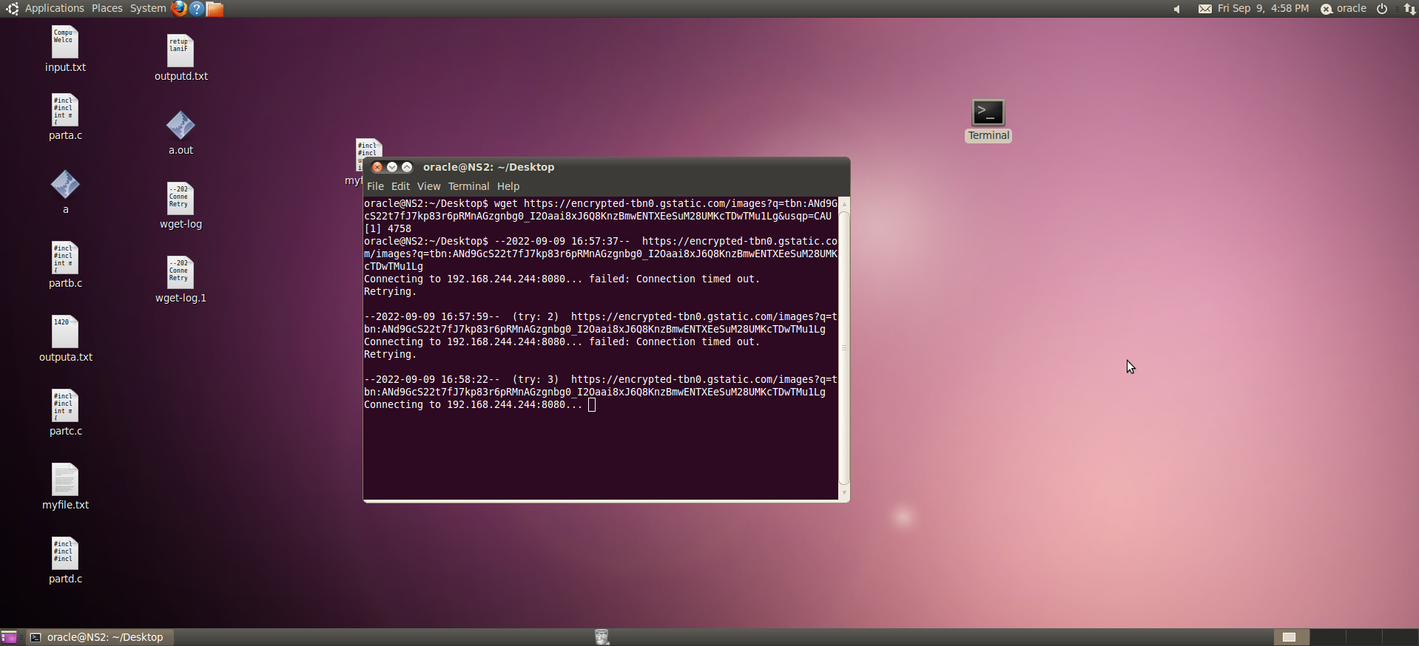

Traceroute:

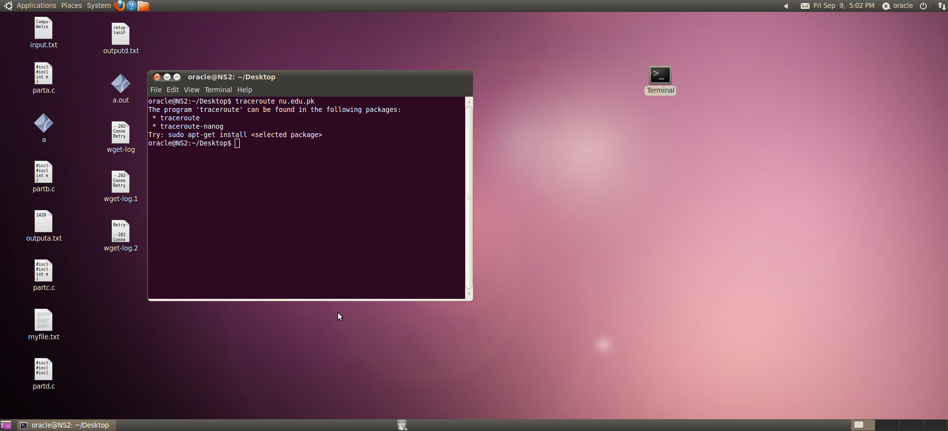

Nslookup:

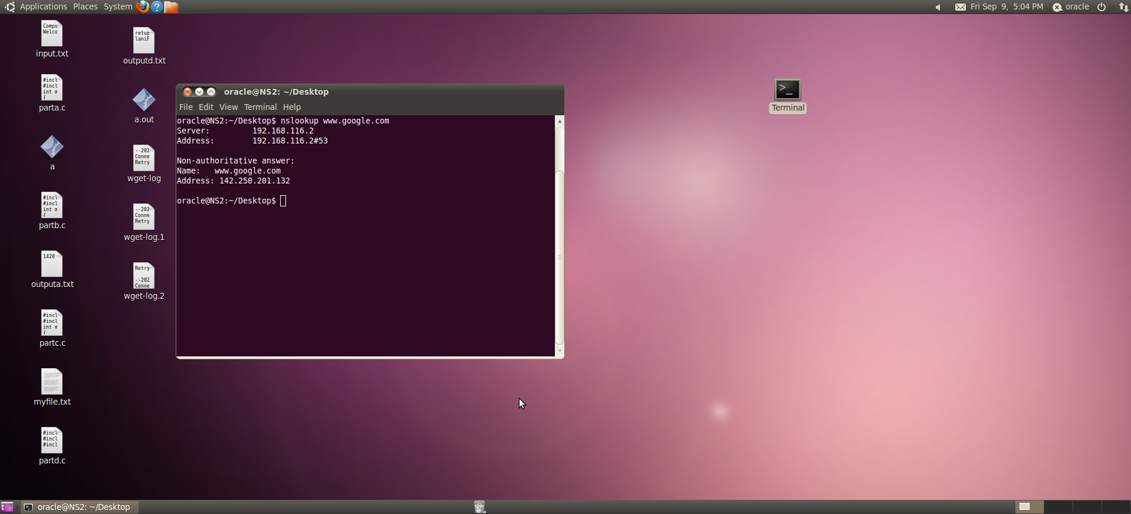

Host:

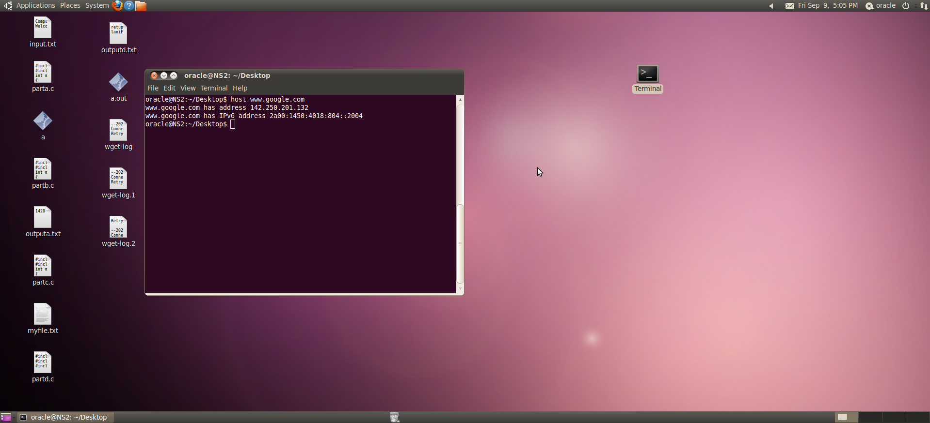

Question 3:

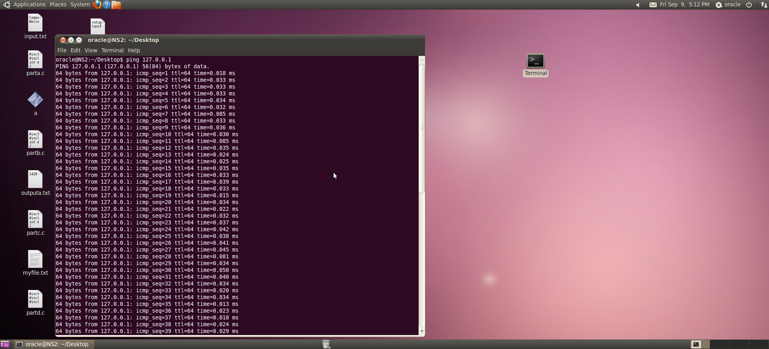





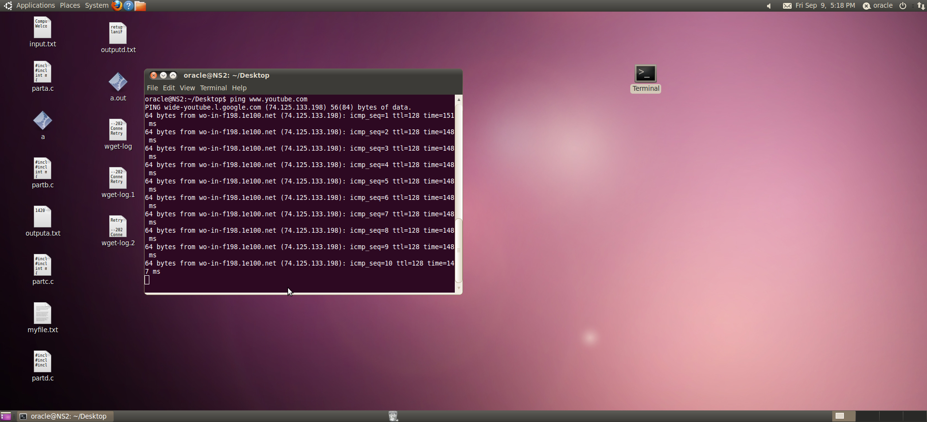

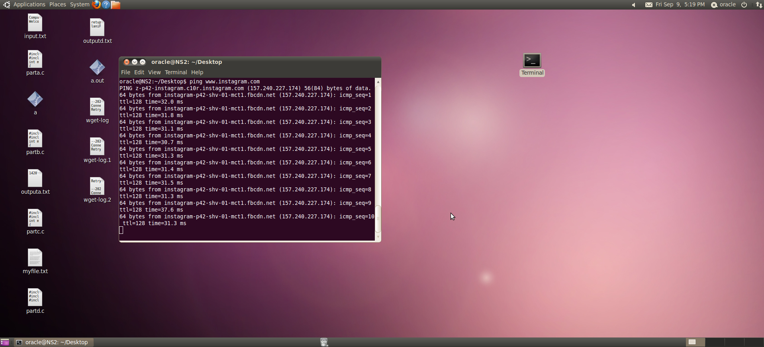

Latency rate is the lowest of my own network.

Question 4:

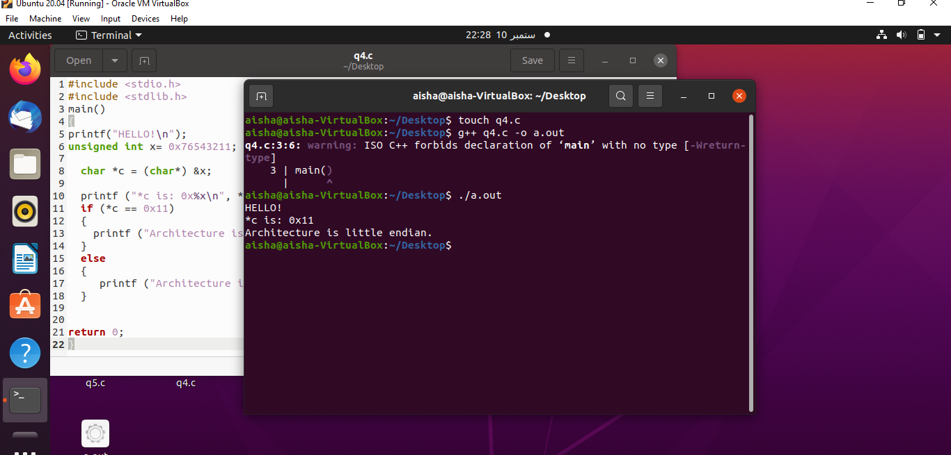

Question 5:

